CODING PRACTICE WEBSITE

**Aim** :- To create website which acts as a platform for users to practice programs in various programming languages

prom as a platform for practising

**Roles and responsibilities of members**

Ajaypal Singh:-

* Complete designing of webpage
* Writing CSS codes of webpage for styling
* Design of pages

Ankit Rawat :-

* Writing part of final report

Ankit Baiskhiyar :-

* Writing part of synopsis

Introduction

This webpage is designed to practice programs in various programming languages like C,C++,Java,python etc.Every programming language need its own platform to compile and execute the program.In that case this website would be very helpful as it can compile and execute code in many programming language.

There is one another advantage of this website.It contains the code library which conatins the problems related to every programming language.Hence,the website is very beneficial for students as it provides a collection of new programs made by the developers.Thus the website acts as a platform both as a compiler and a learning platform.

The website is user –friendly and one can easily use it by logging in or signing up.

Description of Webpages

In this project, we have created a webpage on coding platform with the help of all the concepts we’ve learned so far. We will use **“CSS”** and **“Javascript”** codes to create coding website of our liking.

In this webpage we have created such a smooth and easy interface so that any person can understand and use this website and now the time for description of webpage.

We have created five different tabs in webpage. First *Home*,This page is the main page of the website.On this page you will se top rated problems ,website logo and name,most used languages . Second *practice tab*, this tab will link you to the area wher you can write,compile,run and execute your code. Third *Code Library,* this tab links you to a page which contains various new programs. Fourth *Login tab,* this tab links you to the login page where you can login or signup easily.Fifth Contact Tab,links you to a page where you can ask any query or write your complain.

Our main motive to design this website is to provide our user a user friendly platform and provide every updated program in our library so that a person can easily practice and learn anytime and anywhere.

**Description and Structure of Modules of Pages**

Top Level Components of the webpage

The homepage of the website has the following top-level Components –

1. **Navigation bar**
2. **Main**
3. **Image**

**Navigation bar**

The navigation bar of the page contains the home,practice,code library,login and contact.These all are linked to their required pages using the anchor tag in the ‘index.html’ file.The home page is shown active by using class active in the unordered list in ‘index.html’.The homepage is styled using CSS (‘style.css’).The background image of the homepage is made translucent using rgba(0,0,0,0.6) in the stylesheet.The practice is linked to ‘practicepage.html’ and opens up with a text area and the buttons to compile,run and execute the program.The login is linked to ‘login.html’ and the javascript is used to build a login page and a signup page.The code library is linked to’library.html’ which redirects you to a page containing latest programs.The Contact is linked to ‘contact.html’ and you can write any complains or suggestions here.

**Main**

The main container contains two box and two side box .The side boxes conatins the top rated problems and the most used languages and the other boxes contains example of two problems.Javascript is used to create these boxes.Read more buttons are also created using java script.<span>tag is used for writing the contents of the boxes.

**Image**

The image used as logo is ‘logo.png’ and the background image used is ‘1.png’.The background image used in login page is ‘3.html’.The image is aligned to center and height is adjusted to auto.

**Login Page:-**

The login page uses jquery java script to link the login menu and the sign up menu.Buttons are used in this page like create and login.The html file is ‘login.html’.clickfunction method is used here to use the register button.Login page appears first.

Pages for different routes

The app has routes for the following pages-

1. Home (Highlights Page)
2. Practice (Practice Page)
3. Code library (Library Page)
4. Login (Login Page)
5. Contact (Contact Page)

Screen-shorts of webpages

**In Desktop**

Main page :-

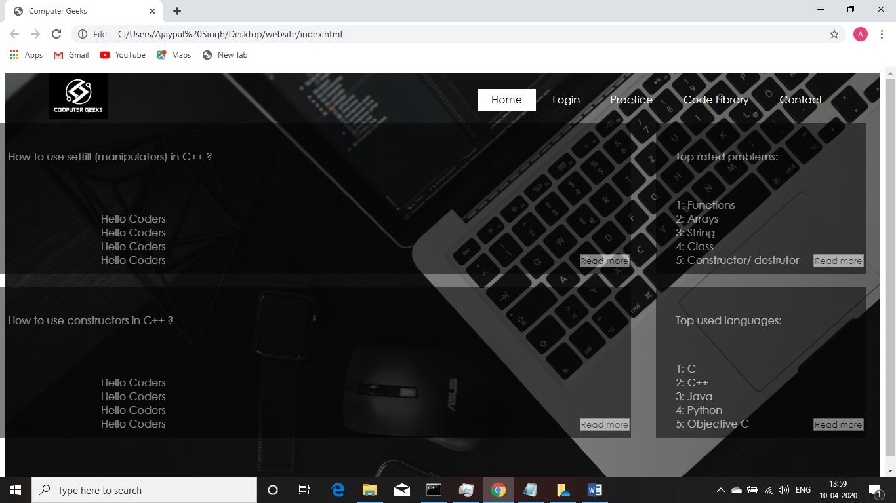

Login page:-

For existing user:-

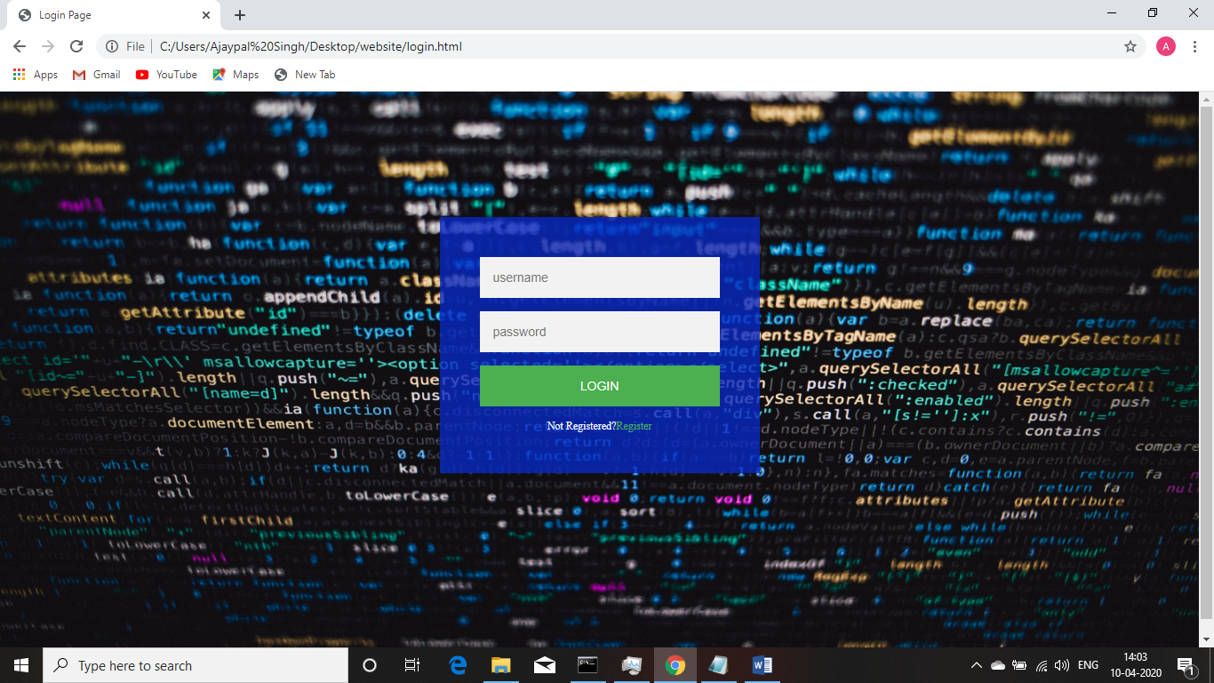

For New User:-

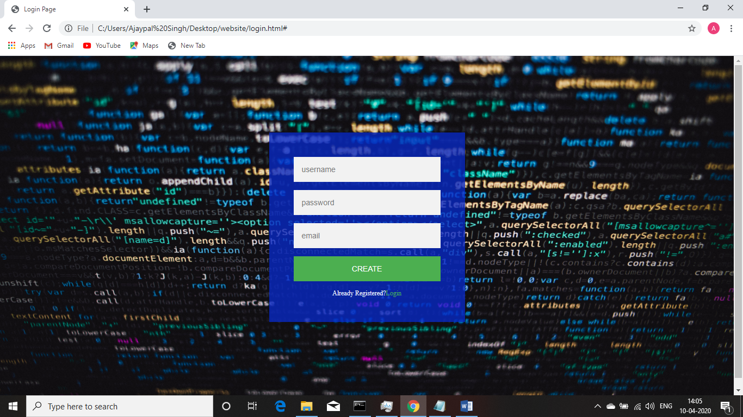

Practice page:-

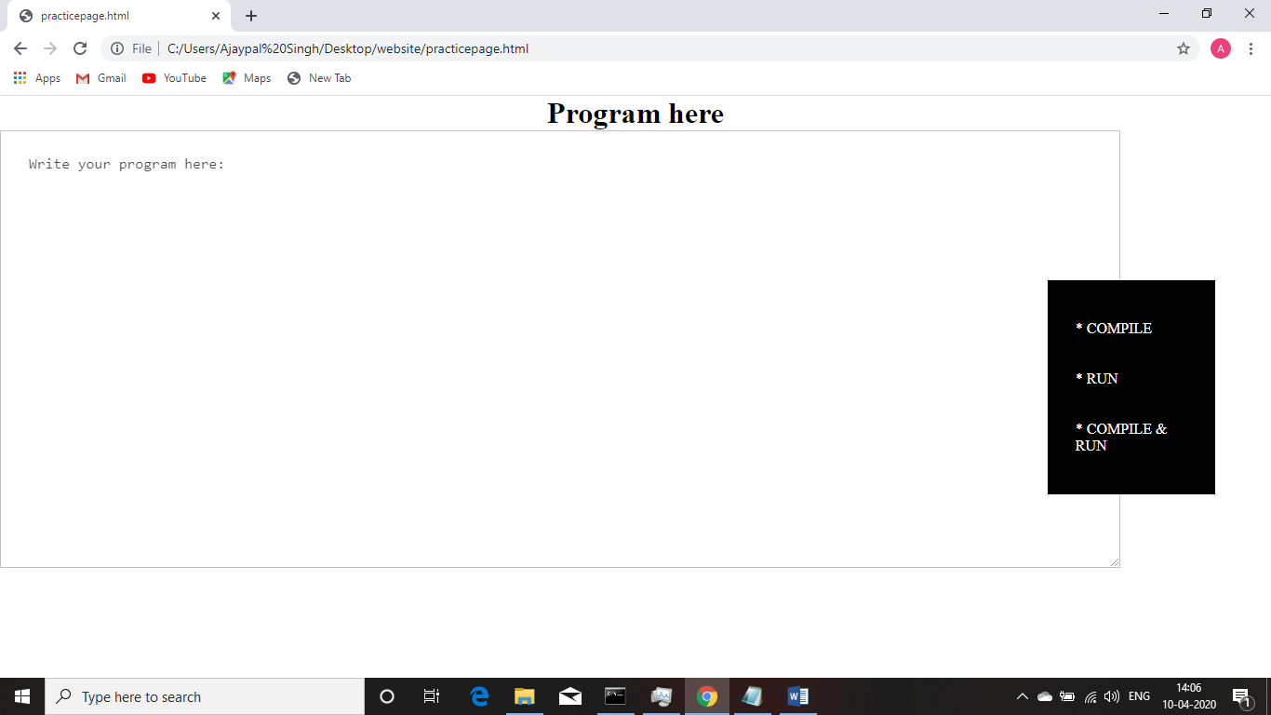

Code Library Page:-

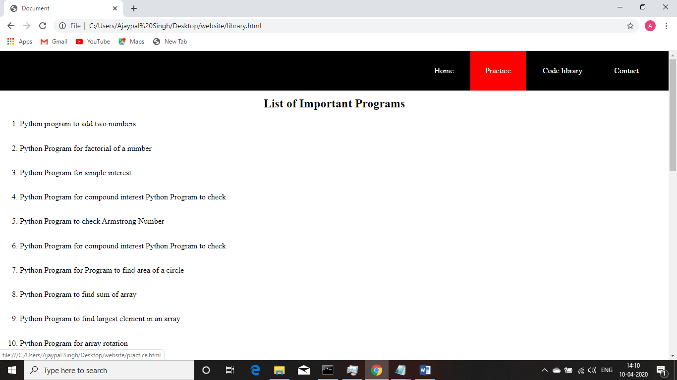

Contact Page:-

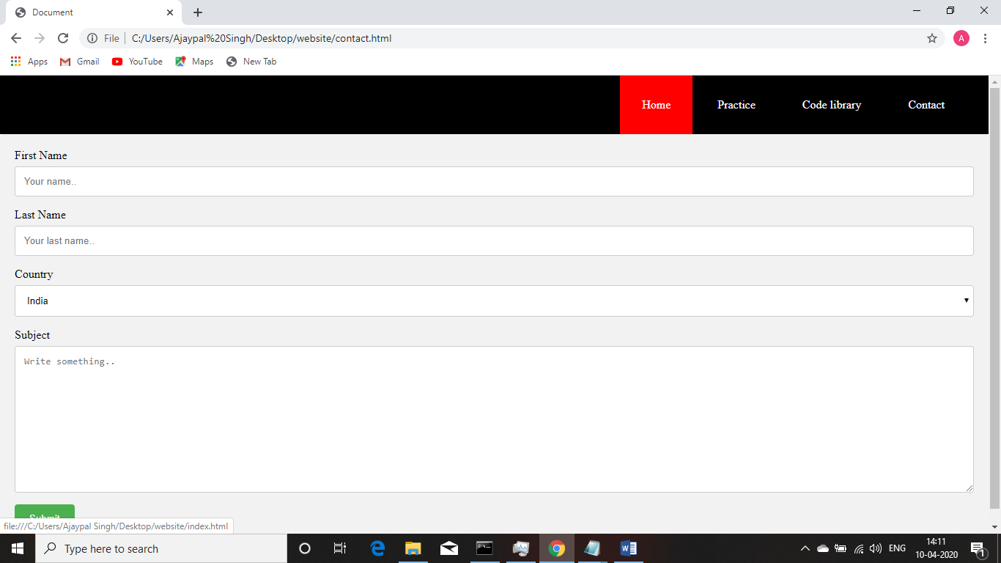

Conclusion:-

Thus the website serves as a user-friendly platform.It provides various new programs and helps in developing coding skills.The site also serves as a platform for compilation and execution of program.

Refrences:-

Self -Made